Imagine Freedom
With Cassielle Bull
A Creative and Moving Journey Towards Wholeness

Imagine Freedom is a celebration of the moving body. Join Cassie for two integrative and healing womens’ circles, coming together in circle to listen and witness each other in these changing times. This exploration and inquiry into the wisdom of the moving body is experienced through authentic movement, art, soul journaling and creative expression, allowing for a deep re-connection with self and other. Feel your own capacity for healing rise as you learn to follow your own impulses and engage in your practice from a place of deep listening, curiosity, wonder and play.

Please bring your journal and something to write with. Art materials will be provided.

Sundays, November 5 and 26, 5 – 7:15 pm, by donation
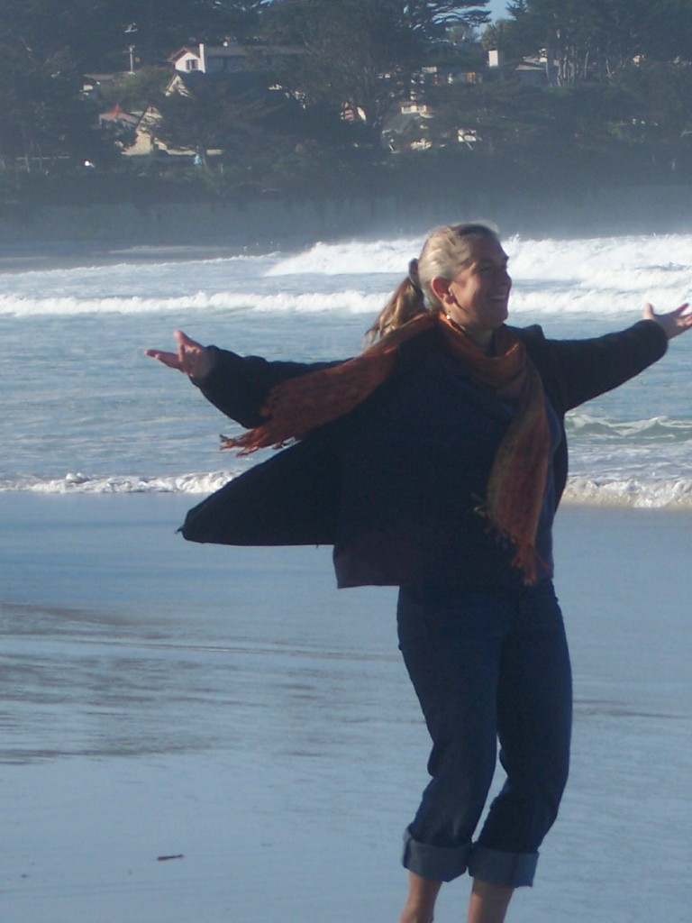

Cassielle Bull, MA, BC-DTR is the Resident Artist at the Maacama Retreat Center in Calistoga, California where she also co-directs LEAPNOW, an organization dedicated to experiential education for young adults. She is a certified yoga teacher and has studied, practiced and taught the healing and creative aspects of movement for over 30 years.

Yoga On Center • 401 Center St. Healdsburg • YOGAONCENTER.COM

